Predicting House Prices in Ames, Iowa
Initial Research Proposal
This project asks: How accurately can we predict a house’s sale price using features such as its size, quality, and age? Following the Kaggle competition’s evaluation metric, we will measure accuracy using root-mean-squared error (RMSE) between the logarithms of predicted and actual sale prices. A lower error indicates better predictions.
We plan to use the Ames Housing dataset from the Kaggle House Prices competition. It contains 79 housing features, 1,460 training observations, and 1,459 test observations. The training set includes actual sale prices, while the test set does not. We will build models using the training set and then predict house prices for the test set.
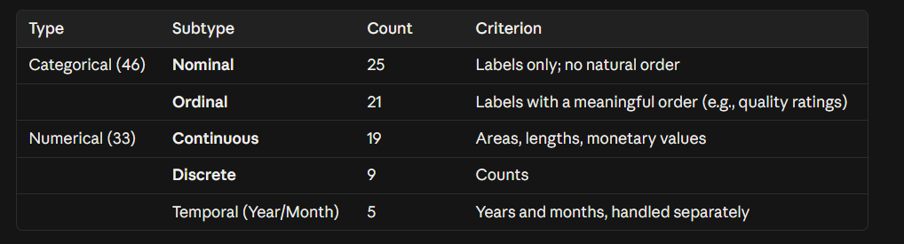
Initially, we will focus on numerical features and ordinal categorical features. Numerical features include living area, lot area, construction year, bathroom count, and garage capacity. Ordinal categorical features include kitchen and basement quality ratings, such as levels ranging from “poor” to “excellent.” We will convert these categories into numbers according to their order.
We will start with a simple regression model and then compare other models using the same data splits. Finally, we will present validation results and generate sale price predictions for the test set.

The features we want to use（title in csv version）
Numerical – Continuous (19)
LotFrontage, LotArea, MasVnrArea, BsmtFinSF1, BsmtFinSF2, BsmtUnfSF, TotalBsmtSF, 1stFlrSF, 2ndFlrSF, LowQualFinSF, GrLivArea, GarageArea, WoodDeckSF, OpenPorchSF, EnclosedPorch, 3SsnPorch, ScreenPorch, PoolArea, MiscVal
Numerical – Discrete (9)
BsmtFullBath, BsmtHalfBath, FullBath, HalfBath, Bedroom, Kitchen, TotRmsAbvGrd, Fireplaces, GarageCars
Numerical – Temporal (5)
YearBuilt, YearRemodAdd, GarageYrBlt, MoSold, YrSold
Ordinal Categorical (21)
LotShape, LandSlope, Utilities, OverallQual, OverallCond, ExterQual, ExterCond, BsmtQual, BsmtCond, BsmtExposure, BsmtFinType1, BsmtFinType2, HeatingQC, KitchenQual, Functional, FireplaceQu, GarageFinish, GarageQual, GarageCond, PavedDrive, PoolQC

